1. Update Existed Account (Diagram 5.1 Version 1.0 11/24/2015)

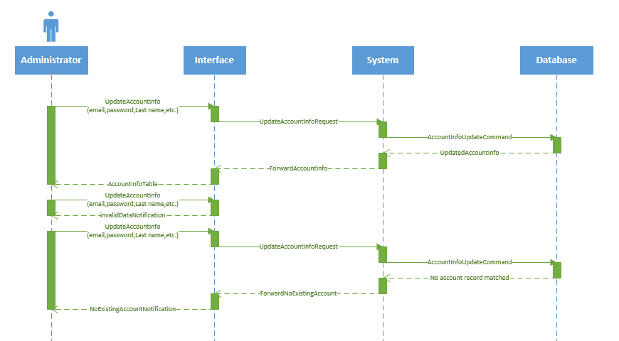

1. Create New Account (Diagram 5.2 Version 1.0 11/24/2015)



1. Delete Existed Account (Diagram 6.3 Version 1.0 11/17/2015)



1. Update All Record (Diagram 5.4 Version 1.0 11/24/2015)



1. Delete Record (Diagram 6.5 Version 1.0 11/24/2015)

